Shawl Shapes
Lenora Francois Stewart

Shawls can be made in many geometrical shapes. In general, a shawl is a piece of fabric – woven, knit, crocheted or felted – that is draped over the head, shoulders or wrapped around the body. It is worn for decorative purposes, religious purpose or to provide warmth.

In the knit & crochet world, the square, circle, or triangle are often manipulated and combined to create unique shapes of fabric.

Before selecting a shape, yarn and tool, remember these basics.
- Shawls need to drape well. Use a hook or needle that is 1 – 3mm larger than is recommended for the yarn selected.
- Edge stitches must be worked loosely. Edges that are too tight will not block well and might be uncomfortable to wear.
- Almost any shawl can be embellished with beads, a unique edging, or with embroidery layered over the base stitches.
- Working increases and lace are the reason stitch markers were invented. Use stitch markers!

Two Basic Methods
Flat: Worked in rows with instructions written for right side and wrong side even if both sides are equally attractive. Easy to change direction and add new shapes. Shawls worked in rows can start small and get big or start big and decrease to just a few stitches. Think triangle, rectangle, and semi-circle. These shapes often are broken into sections of different colors or stitch patterns, but the basic outer shape remains.

In-the Round: Worked from center out beginning with just a few stitches. The stitch count increases at a mathematical rate. Often several lace patterns are included in the same piece. Think circle, square, swirl.

Shawls Worked Flat In Rows

The reference sheet on the next page is reprinted and used with permission of Derya Davenport – www.laylock.org.

- Modifications to these basic shapes are very easy: coloured stripes, textured stripes, different stitches, m1s instead of yos, etc. Crocheters can easily add a chain or extra stitches or change the stitch pattern.
- Knit the shawls with any yarn from lace-weight to bulky. If you’re working in garter stitch or single crochets with no open work, go up a hook/needle size or two, to get a fabric that drapes nicely. The most important thing is that you like the way the fabric drapes and feels.
- The square, circle and semi-circle shawls will not be perfect in shape, but they can be blocked to be this way. For a (pretty much) perfect square or circle, it would be best to work in the round. And for a less semi-hexagonal (no points at lower hem) semi-circle, distribute increases across the row in a less linear fashion.

Notes:

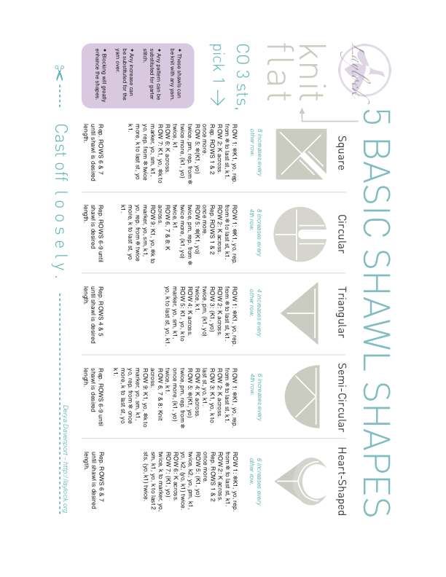

Shawls Worked In The Round
Center Out

The reference sheet on the next page is reprinted and used with permission of Derya Davenport – www.laylock.org.

- The cast on, can be a bit fiddly even for experienced knitters. Crocheters will think they are making a top down hat (easy peasy).
- Any increase can be substituted for the yo’s; crocheters will add in a chain, extra stitch, new pattern, etc..
- Elizabeth Zimmermann reminded us that the for the circle shawl (often called Pi Shawl), the number of rounds doubles between each increase round. Often lace patterns are used to hide those increases – but any increase will work.
- Any of these can be knit in any weight yarn, and you just keep knitting until you:
  - Get bored,
  - Need the hook/needles for another project,
  - Become convinced your stitch count has more figures than your income,
  - Or you decide your shawl is large enough.

Notes:

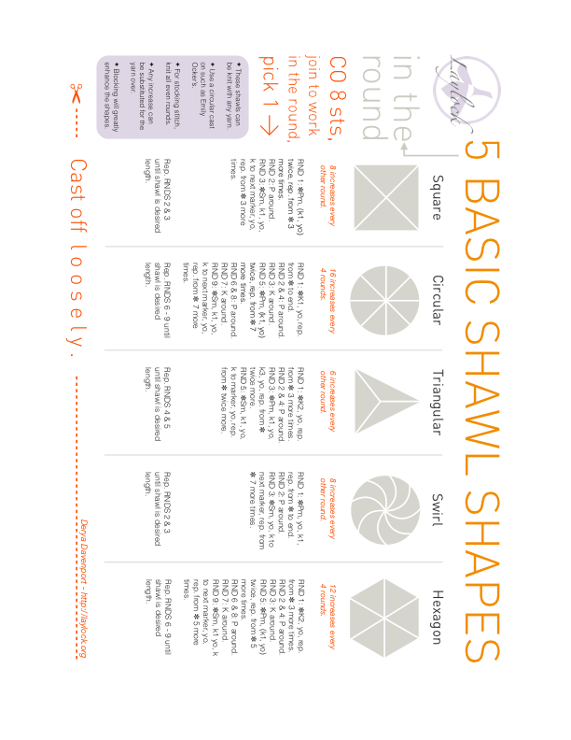

But Wait. There’s More!

Resources:
https://knitting.today/shawl-design-for-everybody/ Fun free stuff for designing your own shawl.

http://crochetkim.com/freepatterns/fun-with-shawl-shapes/ Kim Guzman’s info on crochet shawl shapes that she loves.

https://knitting.today/shawl-design-for-everybody/ Fancy (free) shapes for designing knit shawls.

https://knitting.today/faroese-shawl-design/ For those interested in a challenge – check out the knit Faroese designs.

https://www.craftsy.com/blog/2015/02/top-down-knit-shawls/ Great information in this Craftsy blog.

